Enabling breadth, depth and relevance in
the A Level independent investigation

For this tutorial, it will help if you can access both the tutorial and the given website links at the same time. If you can, be ready to work on a device(s) that will allow you to do that.

It will also be useful if you have a geography reference book handy at the start. This could be any geography magazine or journal article, or even your course textbook and could be in an electronic format.

You will be able to make the most of this tutorial if you already have some idea of what the Independent Investigation (NEA) involves. The first two GEO tutorials would be a great starting place if you haven’t already seen them!

Aims for the session

- Make use of literature, geographical models and secondary data to inspire geographical thinking about a topic and location of interest
- Complete worked examples to practice the skill of using literature, models and secondary data to arrive at meaningful investigation aims and bring depth and relevance into each stage of your investigation
- Review how these elements fit into the route to enquiry and where they may help support our Independent Investigation

Adding breadth: using models and geographical concepts

What is a geographical model?
Which themes apply? Either because they feature or do not feature in the area?

Does it link to any events or issues that are important in your area at the moment?

Pick one identified theme you’re most interested in. What questions would you ask to find out more?

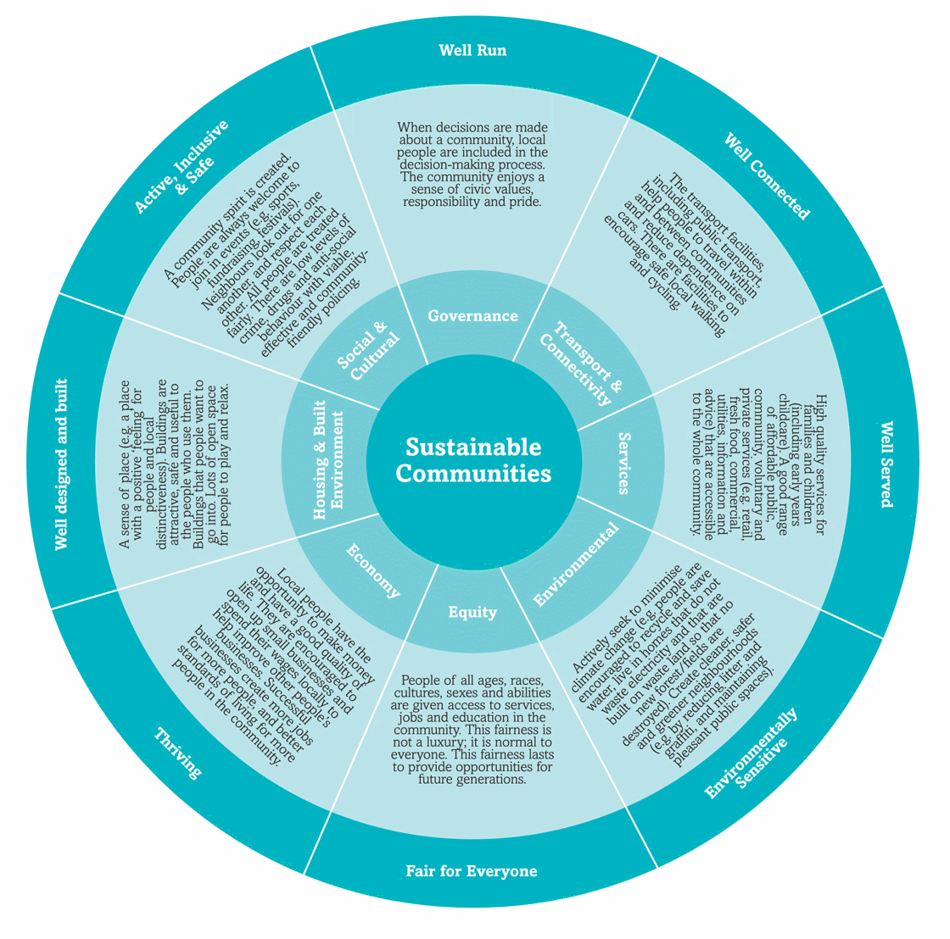

Adding depth: using secondary data

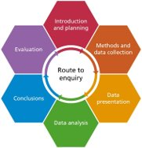

Bringing relevance: using literature
Featured at academic/ theoretical level:
Featured at international level:
Featured at regional/national level:
Local news item/event:

